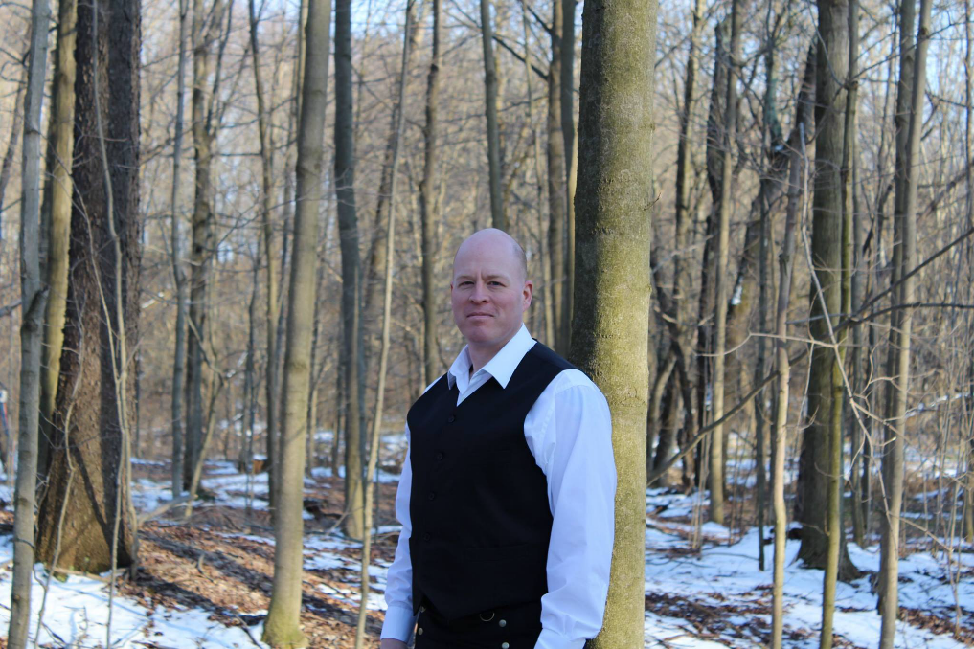
More than one route to Faith…
Recently someone approached me and asked, “Do you believe in God?” Being a polytheist, I considered it a strange question. I nearly responded with a canned response of, “Which one?”
However, I considered the nature of the question. Did they want to know if I was religious, or did they want to know if I had faith in their God?
Faith is a very strong force, one that can divide or unite men and nations, and a force that should never be underestimated. I simply felt that the presumption I was godless to be unfair. I have a healthy respect for the nearly infinite diversity of religious experiences portrayed in the multiple cultures around the world. As a student of religious faith and belief, I am comfortable visiting Christian churches, Jewish synagogues, and Old Time Tent Revivals, so long as I am welcome. It is not because our faiths are the same, but because I have respect for all paths of enlightenment.
Having faith in something is not the same as believing in that same thing. I believe in other deities and forms of divinity, but it does not necessarily follow that I put my faith in them.
A colleague of mine once said that throughout our lives we are all sitting together in a large bowl. Many of us are looking to the ridge, high atop the bowl, and we wonder what is on the other side. So we strive to reach the upper edge, each in our own way, in the hopes that we will eventually find out.
There are many of us Neopagans in the world, Wiccans, Shamans, Spiritualists, and Druids, looking to find our own path to the edge. Never presume that we are without faith or gods, we just have more routes to the top.
Rev. Christopher Temple
Senior Druid and Chief Seer
Whispering Lake Grove, ADF

